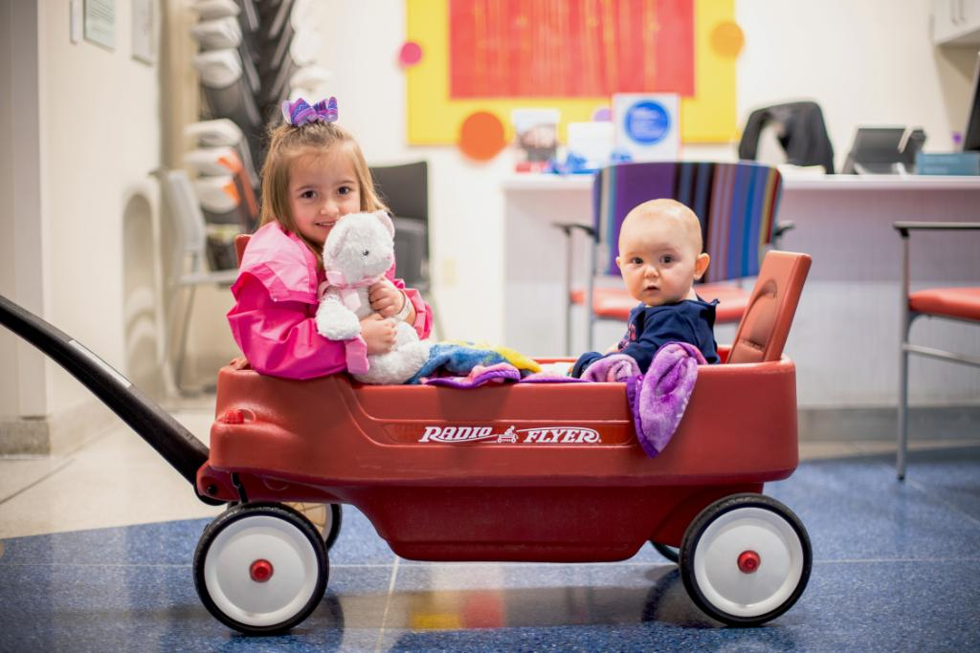

GFWC Missouri’s web page for donating to the Little Red Wagons of Hope for St. Jude is up and running. Make your donations now using the following instructions.

Step 1 Load the following page: http://events.stjude.org/WagonsofHope

Step 2 Select your donation amount

Step 3 Select your form of payment (choices will be credit card or PayPal)

Step 4 Fill in the appropriate information

Stet 5 Donate!

If you prefer to pay by check, make checks payable to St. Jude and mail to:

Amy Boone
PO Box 85
Braggadocio, MO 63826

