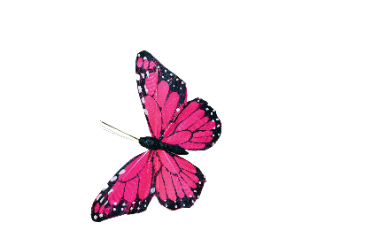
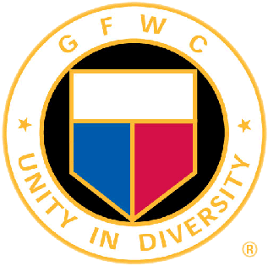
GFWC 2022-2024 ENVIRONMENT
Chairman: Tina Neese, Ed.D., LPC
tinanneese@gmail.com 678-458-0337
Volume Two August 2022 Newsletter

Inside this Edition:

Welcome to the GFWC Environment CSP! It is my pleasure to serve as your chairperson for the 2022-2024 administration. My goal is to provide as much information possible to you for you to be able to pass on important information, project ideas, and facilitate any discussions needed for you to be successful. I will send monthly newsletters and host several meetings for the State CSP chairmen via Zoom throughout the administration. Please always feel free to share this newsletter with your clubs in your state.

If you need to contact me, here is the contact information:

Tina Neese, Ed.D., LPC
1211 Spring Marsh Court NE
Gainesville, GA 30501
Cell: 678 458 0337
Email: tinanneese@gmail.com and tinadaniel1224@gmail.com

Private Facebook Page:
I invite the State Environment CSP chairmen and any Board of Director member to join the private Facebook page: GFWC Environment CSP (GFWC Environment CSP). Various ideas, announcements, guest speakers, and video presentations will be presented.

First meeting for State Environment CSP’s:
September 11, 2022 8:00 EST

- Facebook Private Group:
GFWC Environment CSP
- Important Calendar Dates

Other News in this Edition:
- Understanding the Environment CSP
- Featured Author

Quote of the Month:
“Environment is no one’s property; it’s everyone’s responsibility to protect.” Mohith Agadi

Understanding the Environment CSP
There are four target areas in this CSP:
- Preserve Resources:
This area relates to but not exclusive of forestation, Earth Day activities, reduction of energy consumption, air and water pollution, wetland conservation, water projects, disposable of waste, and gardening. Club Project Example: Prepare a presentation about your watershed for a school or community. Discuss water quality threats, including the dangers of polluted runoff and ecosystem loss.
Free website resources to explore and share with educators and families for children:
www3.epa.gov/recyclecity//
www.eekwi.org
www.eia.gov/kids
www.seacoastsciencecenter.org
www.worldwildlife.org

- Protect Wildlife and Domesticated Animals: This area relates to but not exclusive of birding projects, Audubon Society, native plants for animal food, Department of Natural Resources, preserving Wildlife Management Areas, endangered species protection, wildlife protection, and animal shelter and humane society support. Club Project Example: Be a bird watcher; contribute by gathering scientific data.

- Live Sustainably:
This area relates to but not exclusive of recycling, zero waste projects, the Environmental Protection Agency, sustainable gardening, locally grown food, renewable energy, reduce consumption of purposes, reusable items, and upcycling of items. Club Project Example: Host a fun time with upcycled items for purchase.

- Beautify Communities and Enjoy Nature:
This area relates to but not exclusive of adopt-a-highway, clean up days, nature walks, teaching others about nature, yard of the month, garden tours, master gardening, plant and tree identification, hiking and biking, National and State Parks, and clean water projects. Club Project Example: Be a part of your communities Clean and Beautiful, host a trash pick-up day in your community, or volunteer at a national or state park.

Environment CSP Resolutions
There are 12 resolutions in this CSP as of 6/1/2022. Each month we will explore one resolution and its meaning for GFWC membership. They will be listed in upcoming newsletters after the 2022 convention and any changes are made. This will begin in the Fall.

Kids Corner
Each month find a few environment friendly children book recommendations. Use these books as a stepping-stone to teaching children and teenagers about environmental topics.
The Lorax by Dr. Seuss
We are Water Protectors by Carole Lindstrom
The Curious Garden by Peter Brown
City Green by DyAnne DiSalvo-Ryan
Greta and the Giants by Zoe Tucker
Honeybee by Candace Fleming
The Thing about Bees by Shabazz Larkin
The Hike by Alison Farrell
Winter in the Forest by Rusty Finch

AFFILIATE ORGANIZATION CORNER
Our affiliate organizations offer GFWC unique and customized services including materials, speakers, kits, or other information designed for GFWC clubs.
Heifer International (www.heifer.org): provides gifts of livestock and environmentally-sound agricultural training to improve the lives of those who struggle daily for reliable sources of food and income.
US Fund for UNICEF: to help ensure the world’s most vulnerable children have access to clean water and more. GFWC has supported UNICEF for more than 60 decades.
Important Dates for August
August 4 International Clouded Leopard Day

August 8 International Moon Bear Day

August 12 World Elephant Day

August 13 International Wolf Day

August 15 World Honey Bee Day

August 19 World Orangutan Day

August 26 World African Wild Dog Day

August 30 International Whale Shark Day

World Elephant Day

Find information on how to help elephants at worldelephantday.org. Tweet #WorldElephantDay on social media to spread the word about the plight of elephants. Find sample press releases and other photos on the website to help your campaign.

Sign the pledge to show your support on their website. Don’t support organizations that exploit or abuse elephants (or other animals) for entertainment and profit.

Do not purchase ivory. Be an elephant aware consumer! The following states have made it illegal to purchase: CA, NJ, NY, HI, OR, NV, and WA. It is being considered in the following states: NE, PA, DE, and MA.

Visit elephants in their natural environment with eco-tourism operators who support conservation projects.

Find a list of organizations on the website that support elephants, their habitats, and illegal poaching.

Learn more about fair-trade coffee trades. Many that are not have decimated habits. Buy products certified by the Forest Stewardship Counsel, which promotes responsible management of the world’s forests.

Talk about elephants at local schools – start a study group!

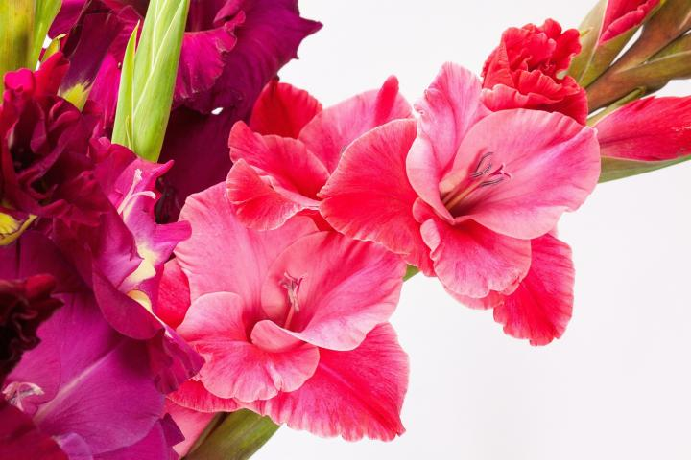Flower of the Month: Gladiolus
The birth flower for August is the gladiolus and the poppy. Focusing on the gladiolus, it symbolizes remembrance. It comes in a variety of colors and make for great cut flowers.

This flower means strength and love. It provides height to the garden and a much needed color splash for the final full month of summer. Colors range from white, pink, red, purple and yellow to name a few. The colors all represent a different meaning.

It is native to Africa, the Mediterranean, and southern Europe. The flower was first brought to Europe in the mid- 18th century. It became popular in the US at the turn of the 20th century and led to the creation of the American Gladiolus Society in Boston in 1910. It has 300 species and a range of colors. It is also known as the sword lily and received its name from the sword-like appearance of its leaves. Gladiolus comes from the Latin word “gladius”, which means sword.

The stalk appears in early summer and can produce 2 to 5 feet foliage. They will bloom in mid to late summer. This flower prefers full sun and a rich, well-drained soil. It can adapt to most other soils though. It does require protection from strong winds. In cold areas, the bulbs should be dug up in the fall and replanted in the spring.

This flower has been associated with moral character, remembrance and intelligence. In Victorian times, it was believed the beauty of the flower could pierce another’s heart with love. So, this flower was often associated with infatuation, love at first sight, and faithfulness.

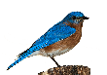
Bird Buzz
The hummingbird is a fascinating bird to watch. They are only a few inches long. They flap their wings so fast they create an actual humming sound, which is how they received their name.
These birds are beautiful to watch and add flavor to your garden area. Here’s some fun facts about these hummers:
They are nicknamed “hummers”.
Hummers choose their favorite locations based on geography, nectar and feeding sources.
They have amazing memories. They can remember every flower and feeder they have visited.
They can fly thousands of miles every year. They go the farthest of any bird in portion to their body size.
The rufous hummer has the longest migration and covers 3,000 miles from Alaska and Canada to southern Mexico.
They can travel 500 miles nonstop.
They are diurnal, meaning they sleep at night and are awake during the day.
There are 350 known hummingbird species and they are either located in North or South America.
They love sugar! They can eat more than twice their weight daily, visiting hundreds of flowers to do so.
Natural nectar is best (instead of dyed). Mix four parts boiling water with one part refined white sugar.
They are attracted to the color red.
Their feeders should be cleaned weekly with a vinegar-water solution.
They do eat insects.
Their brains are heavy compared to the rest of their bodies. It makes of 4.2% of their body weight, the most in the entire wild bird group.
Our States
Learn each month about a different states from their flora and fauna to state birds, trees, flowers, and parks.
Featuring: Alaska
Alaska is known as the “Last Frontier” and entered as the 49th state in 1959. The capital is Juneau and Anchorage is the largest city. The first people came to Alaska 13,000 years ago from Russia or landed by ship. Russians settled in 1784 and in 1867, the US purchased the land for two cents an acre. Many thought it was a bad buy until gold was discovered in 1872. Indigenous people include the Inuit, Tlingit, Haida, Aleuts, Athabascans, and Yup’ik. Alaska’s name came from the native Aleut word Alyeska which means “great land”.

State Bird: Willow Ptarmigan
State Flower: Forget Me Not

It is land to the largest glacier in North America, the Bering Glacier. Denali National Park hosts the tallest mountain (Denali) in North America. There are over 40 active volcanoes in Alaska.
If you have traveled to Alaska, it is a vast place. I was fortunate to travel in July 2022 and visit some amazing places and see things not seen in other parts of our country.

Photo: Glacier Bay

Alaska has eight National Parks: Denali, Gates of the Artic, Glacier Bay, Katmai, Kenai Fjords, Kobuk Valley, Lake Clark and Wrangell-St. Elias. The state has numerous state parks and recreation areas. Wood-Tikchik State Park is the larges state park in the US and comprising some 15% of total state park land in the US.

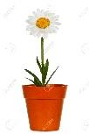
Community Connection Initiative:
Growing a Community Garden
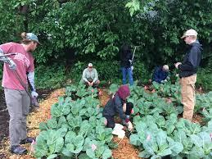
What is a community garden?
Community gardens provide space for members to grow fresh, healthy food close to home. They provide space for powerful neighborhood-level social change.
Community gardens have been a long-standing tradition. During WWII, victory gardens were an important source of food for families. Gardens can also be located on a school campus, library, or park.
What are the benefits?
- They bring places to befriend your neighbors. They would also be a place to recruit new club members.
- They are places to learn. Host gardening classes, instructional tours, or place the garden in a school yard.
- They are sites for restoring and building health. It is considered mild to moderate exercise. There are studies showing it also benefits mental health for people of all ages.
- They are a place to practice teamwork.
- They are a place for children (and adults) to explore nature, sometimes in the middle of an urban area.
- They empower us to organize and advocate for ourselves and our community.
- They provide the opportunity for people in marginalized groups to fully participate and to take on leadership roles.
- They create the opportunity to identify community assets and to build networks.
- They provide space to carry on our food cultures.
- They provide a space to grow low-cost, fresh fruits and vegetables for people without space to garden at home.
- Produce can be grown to donate to local shelters and those in need.
- Creates habitats for plants and animals and improves the ecology of the area.
- Helps to improve air and soil quality.
- Reduces food miles that are required to transport nutritious food.
- Impacts the lower social-economic residents by increasing access to fresh food, improving food security, improving dietary health, and increasing physical activity.
- Decreased crime rates.
- Teaches useful skills in planning, food production and business.
- Beautify and improve vacant land property values.
How can your club create a community garden?
Research grants provided by the USDA’s Cooperative State Research, Education and Extension Service or area botanical gardens.
Connect with the National Gardening Association to learn more about plant-based education at www.garden.org.
Find useful links at the American Community Garden Association’s website: www.communitygarden.org.
Read about these successful community gardens as you plan your garden: Del Paso CA, San Diego CA, Portand OR, CA Plan, http://nesfp.org/sites/default/files/uploads/guide_to_community_food_projects.pdf, https://www.dhs.wisconsin.gov/physical-activity/foodsystem/gotdirt.htm, and http://www.seattle.gov/neighborhoods/ppatch.
States can offer the “Gold Shovel” Award for those clubs who initiate a community garden.

