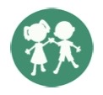
GFWC Juniors’ Special Program:
Advocates for Children
Chairman Katie Robey
kdrobey@robeybaur.org | 508-561-4898

Volume Two October/November 2022 Newsletter

This newsletter is sent to GFWC State Advocates for Children Chairmen, State Directors of Junior Clubs, and State Presidents! Please share it throughout your state. It includes some dates of interest with information and links for more information.

Welcome to our newly announced GFWC Advocates for Children Honorary Chairman-- Stephanie Foster. Ms. Foster was a guest speaker at a recent GFWC Board of Directors Meeting. She presented information from her book, Take Action Fighting for Women & Girls. Quoting from the back cover, the book, “covers the basics of activism and advocacy.” Stephanie served at the U.S. Department of State from 2012-2017. There, she was a Senior Advisor and Counselor to the Ambassador-at-Large for Global Women’s Issues and managed a wide range of key policies and programs, including the Women, Peace, and Security Initiative, women’s political participation, and women’s economic empowerment. As a senior official, she represented the United States in multilateral and bilateral forums and also served at the U.S. Embassy in Kabul, Afghanistan, where she focused on women and civil society and traveled extensively to work with individuals and organizations advancing the role of women in Afghan society. Based on her unique experiences, she understands the political and policy landscapes relevant to empowering women and girls, to increase their opportunities for leadership and growth and to promote a more equal world. Look for articles from her in future editions of this newsletter as well as in Clubwoman Magazine.

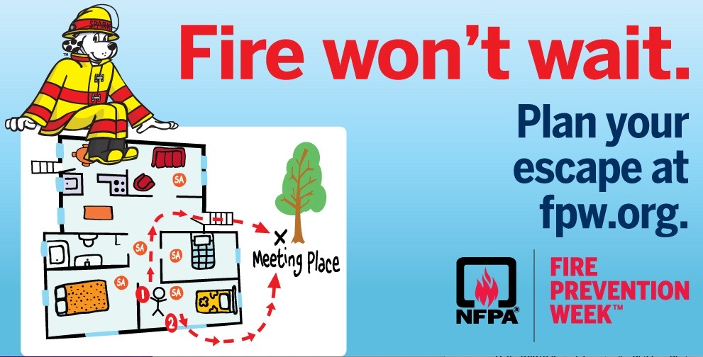
October is National Fire Prevention Month, and this year is the 100th Anniversary of Fire Prevention Week. The goal of Fire Prevention Month (and week October 3rd – 9th) is to raise fire safety awareness and help ensure your home and family is protected. Since 1922, the National Fire Protection Association (NFPA) has sponsored a public observance of Fire Prevention Week. President Calvin Coolidge designated Fire Prevention Week a national observance in 1925. Fire Prevention Week is held each year during week of October 9th to commemorate the Great Chicago Fire, which began on October 8, 1871, and killed more than 250 people. The National Fire Protection Association® (NFPA®) has announced “Fire Won't Wait. Plan Your Escape™” as the theme for Fire Prevention WeekTM, October 9-15, 2022, reinforcing the critical importance of developing a home escape plan with all members of the household and practicing it regularly. You can find more information here: https://www.nfpa.org/Events/Events/Fire-Prevention-Week/About

October 23-29, 2022 ~ GFWC Advocates for Children Week
This special week provides all GFWC clubwomen an opportunity to use their inner sparkle and work together to make a difference in the life of a child. It is suggested the club projects completed during Advocates for Children Week have an emphasis on children whose lives are impacted after being removed from their homes due to unsafe conditions through a collection of personal hygiene items, clothing, and blankets that can be delivered to local organizations serving these children. Take photos and send them to your local newspapers and TV stations and highlight how you, our grassroots members are a part of the GFWC Sparkle Squad.
Use the GFWC Member Portal and find the Advocates for Children pages in the Club Manual under C. On the last page is a fillable proclamation that can be sent to your governor’s office. Take a photo of the proclamation and send it to kdrobey@robeybaur.org and help meet this chairman and GFWC Director of Junior Clubs Katie Moydell’s goal of receiving at least 20 photos from clubs.

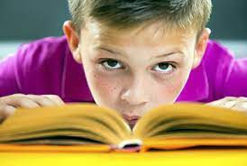
November 14-18, 2022 ~ National Young Readers Week
Children learn between 4,000 to 12,000 words per year by simply reading, no matter what book it is! Young Readers Week raises awareness about the importance of reading, and it is a great time to help kids develop a fiery passion for reading. Celebrate Young Readers Week by teaching children all about the joys of books and literacy by being involved in a classroom or a library or even in your own home.

November 14, 2022 ~ United Nations World Diabetes Day
According to the World Health Organization, one hundred years after the discovery of insulin, millions of people with diabetes around the world cannot access the care they need. The frequency of diabetes is rising around the world, and studies are showing children are at increasing risk of developing the disease. Type 1 diabetes (sometimes called insulin-dependent, juvenile, or childhood-onset diabetes) occurs when the pancreas does not produce enough insulin, a hormone that regulates blood sugar. The cause is not known, but it is thought to be the result of a combination of genetic and environmental factors. Many countries are documenting higher numbers of newly diagnosed cases of type 1 diabetes, particularly in younger children. Interestingly, some disease patterns among children resemble infectious disease epidemics. Currently, there is no known way to prevent Type 1 Diabetes.

November 20, 2022 ~ United Nations World Children’s Day
First established in 1954 as Universal Children’s Day, World Children’s Day promotes international togetherness, awareness among children worldwide, and improving children’s welfare. November 20th is also the date in 1959 when the United Nations General Assembly adopted the Declaration of the Rights of the Child and the date in 1989 when the United Nations General Assembly adopted the Convention on the Right of the Child. This year’s theme is “A better future for every child.” You can learn more here: https://www.unicef.org/world-childrens-day. #WorldChildrensDay
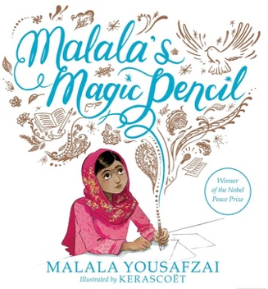
The United Nations General Assembly held a summit on September 19, 2022, on transforming education and called on the Nations of the world to ensure that children everywhere don’t fall behind. Malala Yousafzai, a Noble Peace Prize Laureate, was a speaker. She stated, “Seven years ago, I stood on this platform hoping that the voice of a teenage girl who took a bullet in standing up for her education would be heard,’’ said Nobel Peace Prize Laureate Malala Yousafzai, a UN messenger of peace. “On that day, countries, corporates, civil society, all of us committed to work together to see every child in schools by 2030. It is heartbreaking that halfway through that target date, we are facing an education emergency.” The percentage of 10-year-old children in poor and middle-income countries who cannot read a simple story increased to an estimated 70 percent, up 13 percentage points since before the pandemic shuttered classrooms, according to a report from the World Bank, UNESCO, and UNICEF.
(I recommend several books about Malala. They can be read during National World Reading Week or anytime--I Am Malala: How One Girl Stood Up for Education and Changed the World, I Am Malala: The Girl Who Stood Up for Education and Was Shot, Malala’s Magic Pencil, We Are Displaced, My Name is Malala, and Malala Speaks Out)

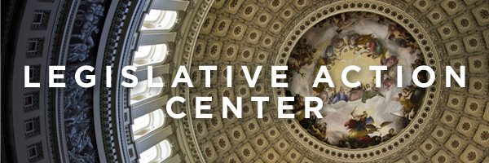

Have you signed up at GFWC’s Legislative Action Center? If not, please do so by checking information here: https://www.votervoice.net/GFWC/home. Once signed up, be on the lookout for information about Preventing Online Sexual Exploitation of Children and the EARN IT Act. This act was approved by the Senate Judiciary Committee in February 2022, but the bill still needs to be voted by Congress and signed by President Biden. You will also hear about the Kids Online Safety Act and the Children and Teens’ Online Privacy Protection Act.

GFWC ANNOUNCES

GFWC FRIENDSGIVING ~

A NATIONAL EVENT
Why GFWC Friendsgiving?
Friendsgiving is the blend of the words Friends and Thanksgiving, and it refers to a large meal shared with friends either near or on Thanksgiving. But why should GFWC Clubwomen make this concept of a meal with friends just for Thanksgiving time?
The GFWC Strategic Plan indicates the development of a National event to assist with building recognition of our grassroots clubs as well as that of The General Federation of Women’s Clubs. The GFWC National Event: GFWC Friendsgiving was announced as one tool to help build the GFWC brand in your community by:
- Thanking local leaders, individuals, and businesses who have participated in some way in club projects by their donations of items, time, gift cards, and/or sponsorship
- Educating potential members to the vast reach of club philanthropy and grassroots volunteer dedication
- Bringing past members back to the club to see what they have been missing
Gathering past club sponsors together to make them aware of your efforts of
- Living the Volunteer Spirit.
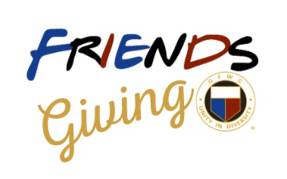
Read all about it in the Member Portal. All the documents you need to put on your own GFWC Friendsgiving can be found on the Member Portal, Digital Library, Folder F, Friendsgiving. This Box of Gems is a party in a box with tips on using this national event to help bring awareness of your club’s activities to all those who have helped your club along the way.

