

**GFWC Legislation/Public Policy Quarterly Newsletter 2022-2024**

**Issue No. 2**

**By Juliet M. Casper, GFWC Southern Region Representative**

**Award Entries**

As 2022 comes to a close, the preparation of award entries allows you to celebrate your club’s achievements and community impact. Did your club hold a candidate forum or voter registration drive? A winning award entry will address the who, what, when, where, how, and why of a project. Ask your members if they responded to one or more of the following 2022 Legislative Action Alerts: Reauthorization of the Violence Against Women Act, the EARN IT Act (S. 3538, H.R. 6544), Childhood Global Vaccinations, or the Family Violence Prevention and Services Act. Be sure to describe any responses received from elected officials. These activities are also items on the GFWC Scavenger Hunt. Your award entries should include the progress made on the hunt. It is not too late to post photos of scavenger hunt items on social media with #GFWCAdvocacy. The data contained in the award entries provides a history of our volunteer and advocacy efforts.

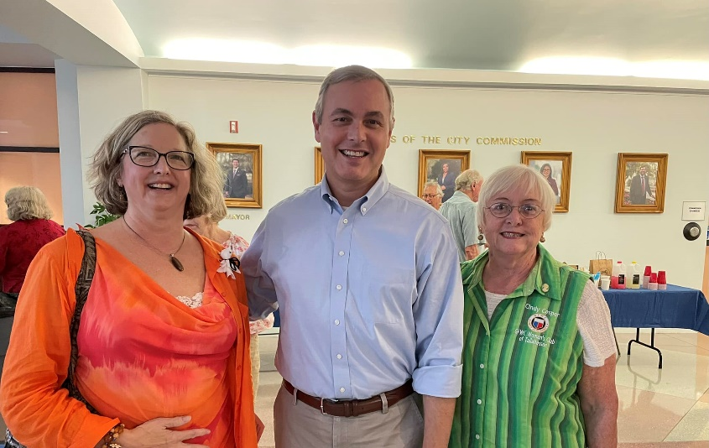

Checking off Item #2 on the Scavenger Hunt, Woman’s Club of Tallahassee Environment CSP members Susan Franklin McLeod and Cindy Cosper with Leon County [Commissioner Rick Minor](https://www.facebook.com/CommissionerRickMinor?__cft__%5b0%5d=AZXNR4ednh_gJWV5_M6IOm1_3W8OyAjW7RagDaW1ZLouiWue8GbPGilduvfzPLXYSP17li2-U_wLVoPj3Y2Kry03W2o3ur-3MY5NARAnEgjXu8gikgIhFrk1GzElq1OKkxPwPsIpqhPR5BnkbA849xdQ&__tn__=-%5dK*F). Bonus points for wearing GFWC attire. [#GFWCAdvocacy](https://www.facebook.com/hashtag/gfwcadvocacy?__eep__=6&__cft__%5b0%5d=AZXNR4ednh_gJWV5_M6IOm1_3W8OyAjW7RagDaW1ZLouiWue8GbPGilduvfzPLXYSP17li2-U_wLVoPj3Y2Kry03W2o3ur-3MY5NARAnEgjXu8gikgIhFrk1GzElq1OKkxPwPsIpqhPR5BnkbA849xdQ&__tn__=*NK*F)

**The Power of You: A GFWC Advocacy Training Series**

In her book *The Education of an Idealist*, Samantha Power said, “People who care, act, and refuse to give up may not change THE world, but they can change many individual worlds.” Are you ready to change your world? Are you ready to move from volunteer to advocate? GFWC is here to help you become more comfortable with legislative advocacy. The Legislation and Public Policy Committee, along with Debby Bryant of Unified Solutions and Darrell Jones, GFWC Programs Manager, are presenting a free webinar series. You will learn civic engagement strategies to influence local, state, and federal government officials. You will see the power of the Legislative Action Center and hear about GFWC’s legislative priorities. GFWC Affiliates will share their advocacy activities and ways for you to advocate on their behalf.

The webinar series is scheduled for each Thursday evening at 7 p.m. ET beginning January 19, 2023. Each episode will be 45 minutes to one hour in length with Q & A as time allows. Register for the entire series or the episodes of your choice. Just go to <https://www.gfwc.org/what-we-do/public-policy/> and click on the title of each episode then complete the registration form. This series is free and will be held via Zoom.

**National Slavery and Human Trafficking Prevention Month**

January is National Slavery and Human Trafficking Prevention Month and can also be known as Human Trafficking Awareness Month. It is a key time for us to educate ourselves about human trafficking, learn to spot the signs of trafficking, and know how to report suspected actions to law enforcement. Hope for Justice, a GFWC Affiliate Organization, investigates cases of human trafficking and works with law enforcement to rescue victims. Check out the website, <https://hopeforjustice.org/>, and watch one of the videos of a survivor story. The U.S. Department of Homeland Security launched the Blue Campaign to educate the public, law enforcement, and other industry partners to recognize the signs of human trafficking and to respond appropriately to possible cases. Here are the common signs which are listed on the website, <https://www.dhs.gov/blue-campaign>:

* Does the person appear disconnected from family, friends, community organizations, or houses of worship?
* Has a child stopped attending school?
* Has the person had a sudden or dramatic change in behavior?
* Is a juvenile engaged in commercial sex acts?
* Is the person disoriented or confused, or showing signs of mental or physical abuse?
* Does the person have bruises in various stages of healing?
* Is the person fearful, timid, or submissive?
* Does the person show signs of having been denied food, water, sleep, or medical care?
* Is the person often in the company of someone to whom he or she defers? Or someone who seems to be in control of the situation, e.g., where they go or who they talk to?
* Does the person appear to be coached on what to say?
* Is the person living in unsuitable conditions?
* Does the person lack personal possessions and appear not to have a stable living situation?
* Does the person have freedom of movement? Can the person freely leave where they live? Are there unreasonable security measures?

Wear Blue on January 11 to raise awareness of this issue and post photos on social media with #WearBlueDay. GFWC has been actively engaged in a coalition hosted by the National Center on Sexual Exploitation to support federal legislation including the EARN IT Act, the Kids Online Safety Act, and reauthorization of the Trafficking Victims Protection Act programs. Congress is currently considering a package of four bills to be assembled into the federal legislation which establishes the framework for the federal government’s response to human trafficking. Most notably, the Trafficking Victims Protection Act (TVPA) of 2022 authorizes critical funding to support survivors and combat human trafficking in all forms both domestically and internationally. It also improves existing efforts to prevent trafficking, protect victims, and prosecute traffickers. Authorization for many of these programs expired September 2021, although federal funding has continued. Current negotiations on TVPA reauthorization include portions of these introduced bills: International Trafficking Victims Protection Reauthorization Act, Abolish Human Trafficking Reauthorization Act, Trafficking Victims Prevention and Protection Reauthorization Act, and the Frederick Douglass Trafficking Victims Prevention and Protection Reauthorization Act.

**GFWC LEGISLATION/ PUBLIC POLICY COMMITTEE**

The members of the GFWC Legislation/ Public Policy Committee are here for you. Please contact the member in your region with any questions you may have. We would love to speak to your state federation or club, in person or via Zoom.

Juliet Casper (SC), Chair Southern [jcasper9200@gmail.com](mailto:jcasper9200@gmail.com) c. 843-446-8479

Esther Gartland (OH) Great Lakes [gartlanddj@aol.com](mailto:gartlanddj@aol.com) c. 330-883-8449

Debbie Fiore (CT) New England [debfioregfwc@cox.net](mailto:debfioregfwc@cox.net) c. 860-882-9553

Carolyn Forbes (DE) Middle Atlantic [mrschefdjf@aol.com](mailto:mrschefdjf@aol.com) c. 302-222-6468

Kathy Huggins (NE) Mississippi Valley [khuggins555@gmail.com](mailto:khuggins555@gmail.com) c. 402-517-6196

Sally Harper (NM) South Central [saharper@nmsu.edu](mailto:saharper@nmsu.edu) c. 575-644-7328

Jennifer Jobe (NC) Southeastern [jenniferwjobe@gmail.com](mailto:jenniferwjobe@gmail.com) c. 336-251-2094

Joyce DeCunzo (MT) Western States [joycedecunzo2018@gmail.com](mailto:joycedecunzo2018@gmail.com) c. 406-439-0076

**TOGETHER We Advocate For Those In Need**